**ABE 557 | Prof. Okos**

**Dryer Design Part 2**

**Nathan LeRoy**

**Nov. 12th, 2018**

**The System and Background**

In this unit operation, we are drying two wheat products continuously in a dryer. The wheat products are known as semolina and farina:

Dry couscous/wheat product

Wet couscous/wheat product

Dryer

In part 1, we determined the moisture isotherm characteristics and curves for our products. With this, we were able to examine how our products psychrometric and thermodynamic properties change with respect to temperature and water content.

We also created the curves for the glass transition temperature (Tg) of our product as a function of moisture content inside the product. This is very important for the drying and processing of the couscous. From here, we can design our dryer and stages around this data. It was given that we want to dry our product at least 10 degrees C above the Tg, but not more than 50 degrees C above the Tg. While drying our product from 0.4 moisture content to 0.05 moisture content, we can dry at a constant temperature until one of these conditions is not met (Fig. 1).

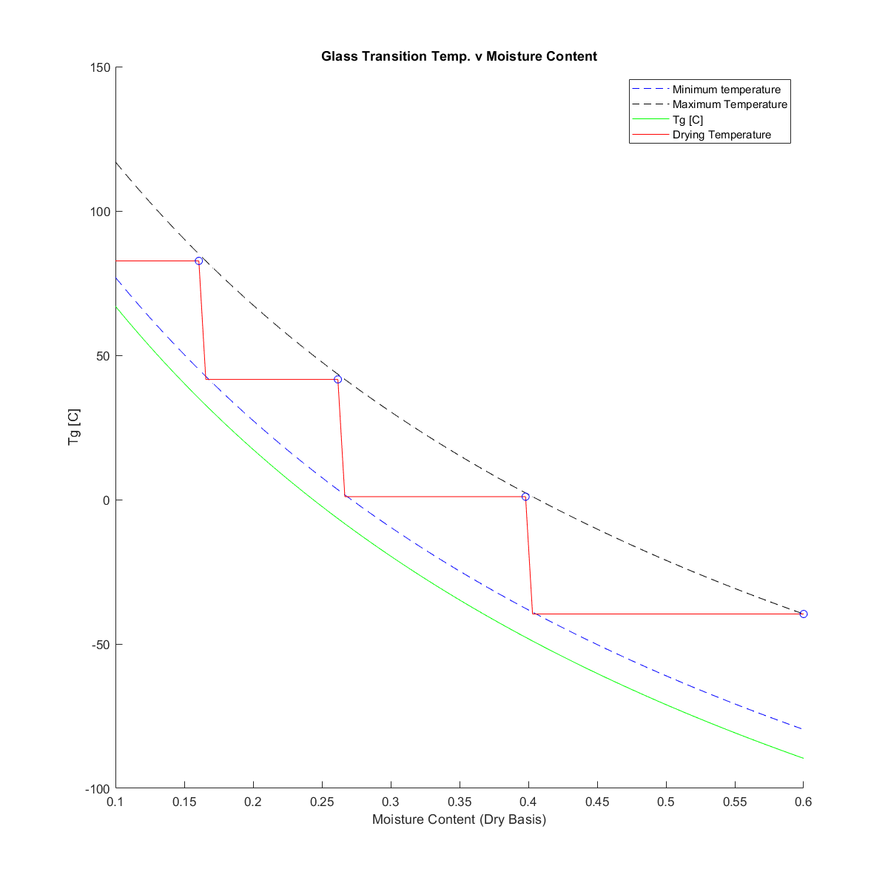

Figure 1 Glass Transition Temperature as a function of moisture content.

In part 2, we wanted to further design our dryer by calculating the residence times inside the system at each stage. To do so, we needed to use the following formula to calculate drying time between two moisture contents:

$$t=\frac{4r^{2}}{πD_{eff}}ln\left(\frac{8X_{i}}{X_{f}}\right)$$

To account for the change in radius and diffusivity, we can numerically integrate and calculate the total residence time in each section for small steps in moisture content. The algorithm for this is given in the Algorithm Steps section.

After finding the residence times in each stage, we wanted to assess the economics of the unit operation. To do so, we examined 4 costs:

* Cost of the conveyor belt
* Cost of heating the air
* Cost of the fan
* Cost of the air pump

The cost of the conveyor belt is directly related to the length of the conveyor belt. To find this data, we assumed a conveyor belt speed, and used the following equation to calculate its length:

$$\left(BeltSpeed\right)\left(ResidentTime\right)=BeltLength$$

And we know that the belt length is related to price with the following equation:

$$Price\left(\$\right)=2e{10}^{4}{\left(\frac{BeltLength}{60}\right)}^{0.85}$$

To heat the air, we can conduct a macroscopic energy balance. Heat to air is equal to the heat lost from steam:

$$GC_{p_{air}}ΔT=ΔHm_{steam}$$

Or

$$\frac{GC_{p_{air}}ΔT}{ΔH}=m_{steam}$$

Where ΔH is the specific enthalpy of our superheated steam. The key parameter here is the mass flow rate of air, G. This is calculated through a series of equations from Geankopolis:

$$G=\frac{h}{c_{p_{air}}J_{h}}{\left(\frac{c_{p_{air}}μ}{K}\right)}_{}^{2/3}$$

And

$$J_{h}=\frac{K}{v_{air}}{\left(\frac{μ}{ρD_{eff}}\right)}^{2/3}$$

Once we know the mass flow rate of the air, we can simply convert it to the volumetric flow rate of the air using the known density of air, and calculate the cost of the air fan with the following formula: $ 103[V(m3/min)/84.9]0.54

Finally, we can calculate the cost of pumping the air through the bed of our product. To do so, we need to know the pressure drop through our packed bed, and then calculate the work done on the air and subsequent pump power requirement:

$$\frac{-∆P}{H}=1.75\frac{ρv_{air}^{2}\left(1-ϵ\right)}{xϵ^{2}}$$

$$-W_{s}=\frac{101.3kPa}{ρ}ln\left(\frac{ΔP}{101.3kPa}\right)$$

$$PumpPower\left(kW\right)=\frac{-W_{s}G}{η1000}$$

And the price of electricity is known to be $0.04 per kWh. With this data, we can assess the economical viability of our process and give marketing and sales people numbers to work with to start creating prices and advertising for our product.

**Algorithm Steps**

*Residence Times -* A nested loop structure was created to calculate the residence times in each section of the dryer. To deal with a change in radius and diffusivity, we had to take the change in moisture content in small increments.

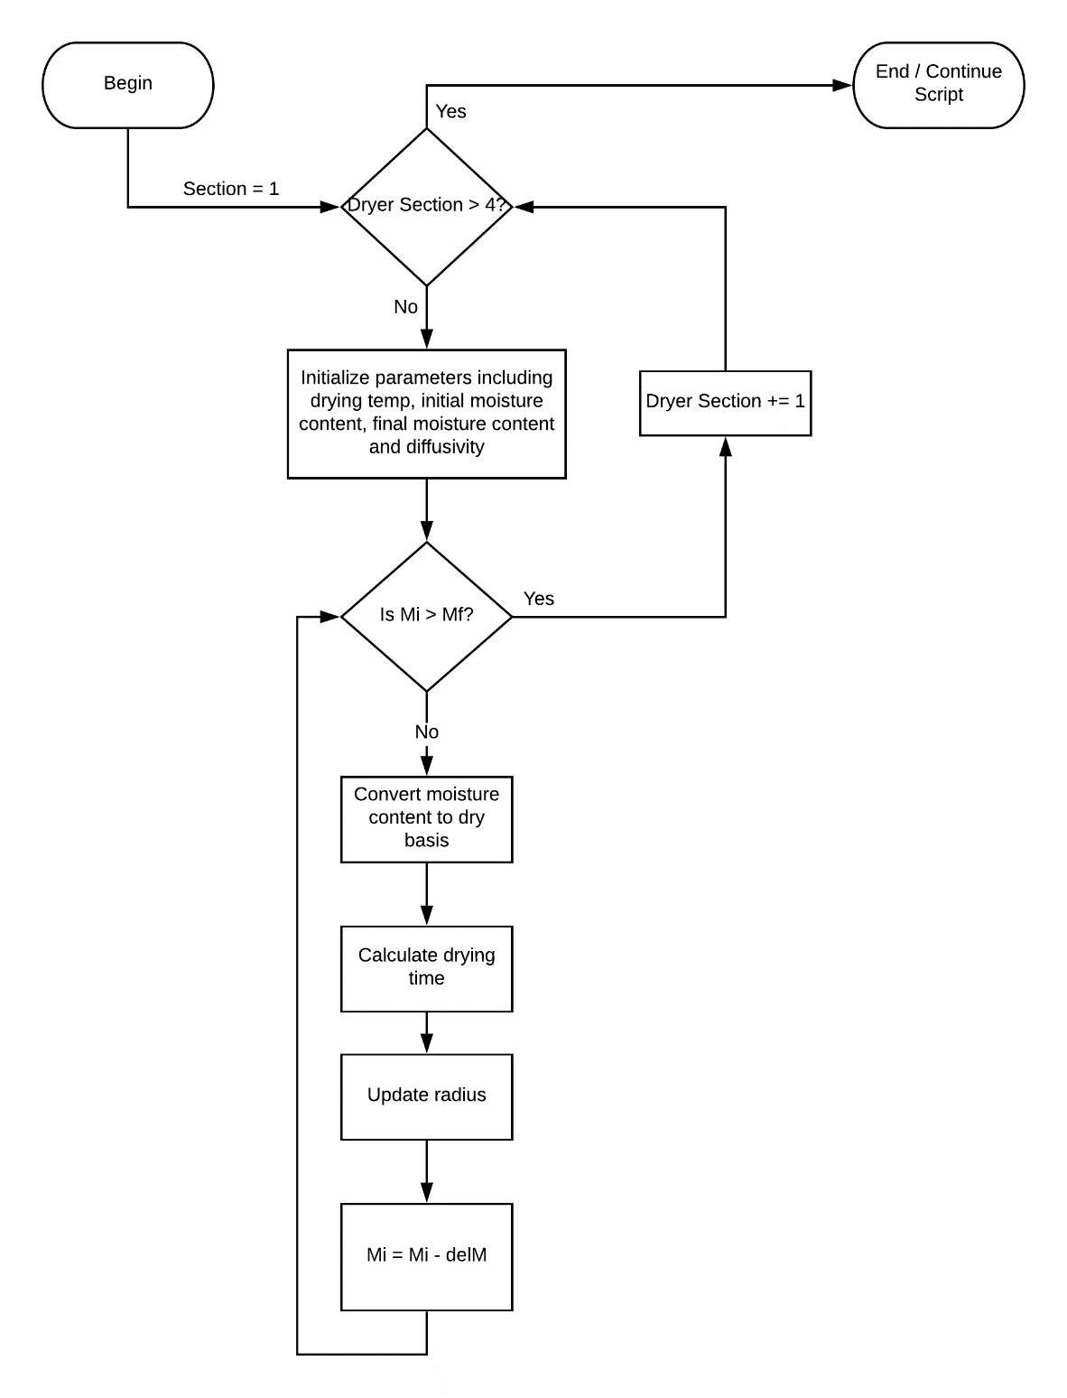

Figure 2 Algorithm flow chart for the residence time calculations.

*Cost Analysis –* The cost analysis was very procedural and consisted of just a linear sequence of calculations in MATLAB to get the required cost estimations. We first calculated the cost of conveyor belts with an assumed speed, then calculated the air mass flow rate to get the fan costs, and the air pump costs. In addition, we used macroscopic energy balances to calculate the amount of steam required to heat the air and estimated those costs as well.

**The Results**

*Residence Times –* A residence time for each section was calculated. The MATLAB script outputted the following results:

A 4 stage dryer using the following conditions:

-=-=-=-=-=-=-=-=-=-=-=-=-=-=-=-=-=-=-=-=-=-=-=-=-=-=-=-=-=-=-=-=-=-

Stage 1: Air at 1.80 C and 6.06% RH for 0.34 hrs

Stage 2: Air at 42.00 C and 0.33% RH for 0.58 hrs

Stage 3: Air at 82.22 C and 0.03% RH for 0.75 hrs

Stage 4: Air at 123.55 C and 0.00% RH for 0.75 hrs

The drying time was plotted in MATLAB. Note that the drying operation occurs from right to left as the moisture content inside our product is decreasing (Fig. 3).

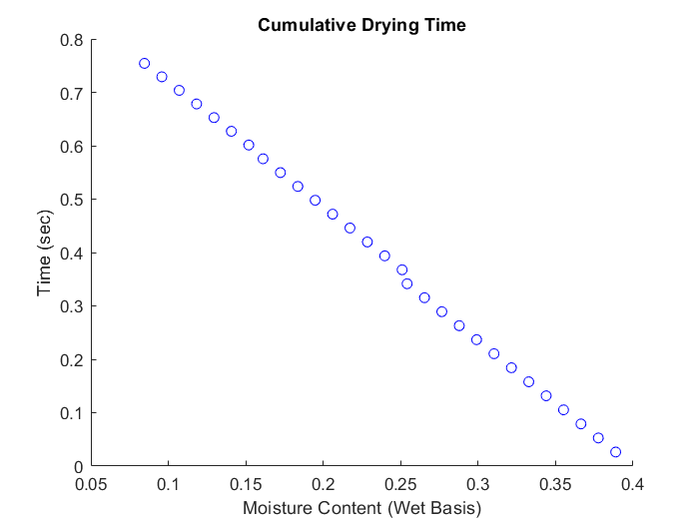

Figure Graph of Drying Time as a Function of Moisture Content.

One can see that the longest drying times are found in the final steps of the drying process. This makes sense. As the moisture content decreases in our product, we will need dryer and dryer air for longer periods of time to achieve a drier product. This result is reflected directly in our belt lengths. We assumed a very slow belt speed of 160 meters per hour which is 0.1 mph. This corresponds to the following belt lengths also outputted by our MATLAB script:

-=-=-=-=-=-=-=-=-=-=-=-=-=-=-=-=-=-=-=-=-=-=-=-=-=-=-=-=-=-=-=-=-=-

Stage 1: Belt length is 54.64 meters

Stage 2: Belt length is 92.09 meters

Stage 3: Belt length is 120.68 meters

Stage 4: Belt length is 120.68 meters

These are long, but not unreasonably long belt lengths. We will see later that the cost of the conveyor belts is the largest financial investment in our process.

*Dryer Schematic –* Below is a schematic of our dryer. We can see the air conditions going into the dryer, and the relative lengths of each stage. Note that this air must be heated prior to being pumped into each dryer section (Fig. 4).

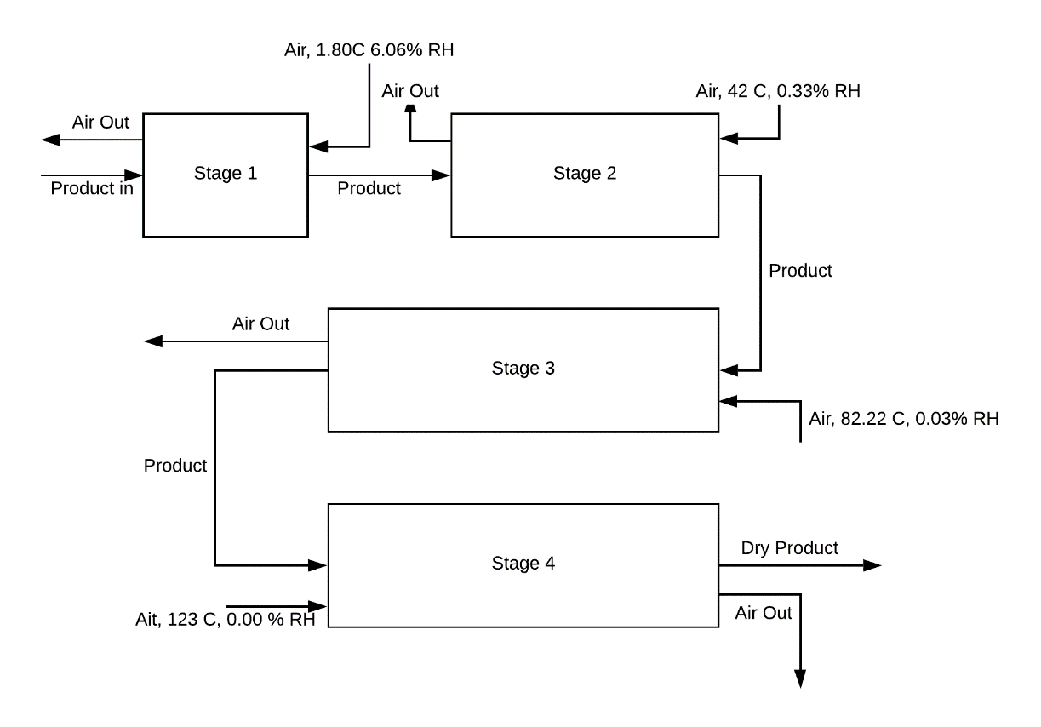

Figure . Dryer Schematic showing each section.

*Cost Analysis –* Please see the background for how the cost analysis was done. The MATLAB script outputted the following values for the cost of each operation relating to the drying of our product:

-=-=-=-=-=-=-=-=-=-=-=-=-=-=-=-=-=-=-=-=-=-=-=-=-=-=-=-=-=-=-=-=-=-

The cost of the conveyor belt is: $359112.58

The cost of the steam is: $783.51 per hour

The cost of the fan is: $14553.44

The cost to pump the air is: $1432.06

It is clear to see that the conveyor belt is the most expensive cost in our drying process. This does make some sense. Steam is cheap, and blowing air is cheap. It does take a considerable amount of energy to push thousands of kilograms of product through a dryer for many hours. Some of these values seem a bit high however. A couple of orders of magnitude off. This may be due to estimations made about the process accumulating to create an expensive cost analysis. It was not stated whether or not the conveyor belt was a one-time cost, or a continuing cost. If it is a one-time cost, then this is not an unreasonable value to get

**Conclusions**

* We get reasonable residence times around 30 – 45 minutes in each section which accumulate to just over two hours total drying time.
* The lengths of our conveyor belt are likewise reasonable. The max section length of our dryer is 120 meters, which is reasonable if not built in a totally linear fashion.
* The cost analysis seems to be a bit high. However, if some assumptions are cleared up and made more specific, things may come together.